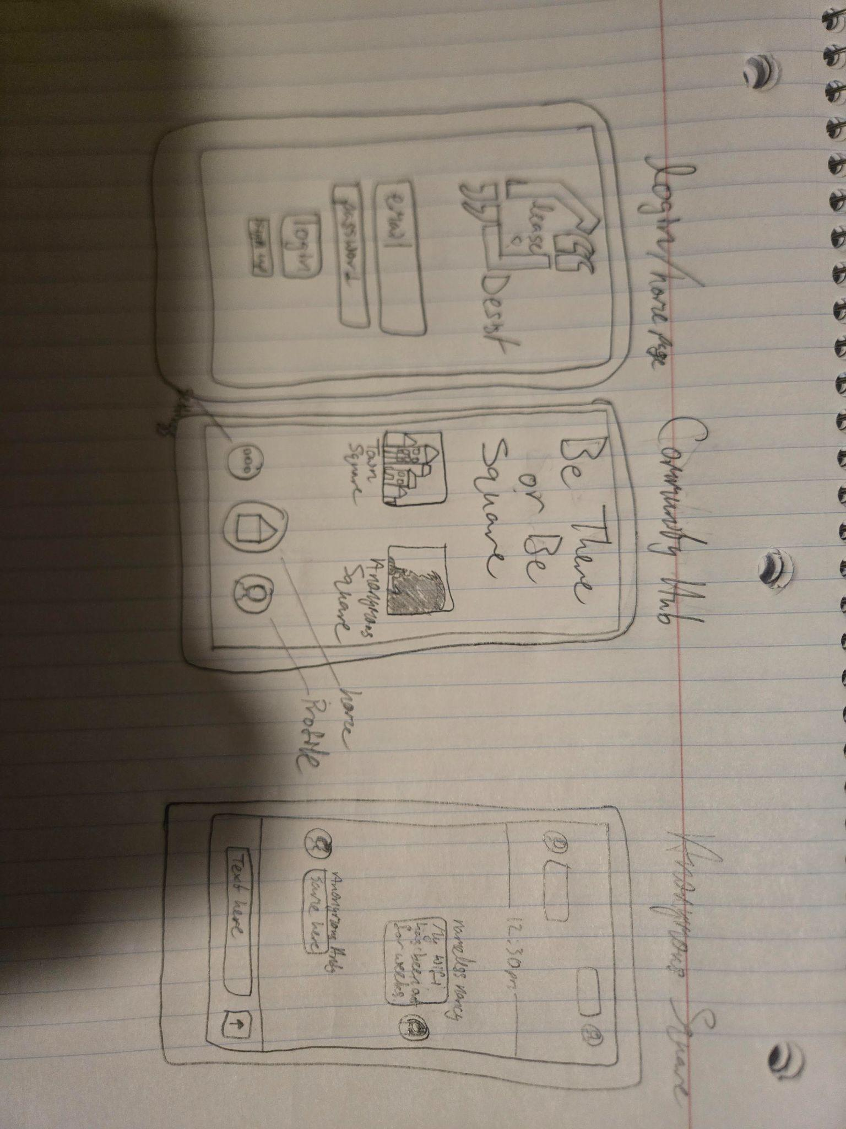
Functional Requirements:
- User Authentication (sign up, login, password reset)
- Create, join, and manage tenant groups
- Real-time chat and message threads
- CRUD for issues/complaints: tenants can Create, Read, Update, Delete reports
- Notifications for new messages or status updates
- Able to search for groups, tenants, or issues
- Role management (e.g., group admin, regular member, RA, etc.)
- File and image sharing (proof of maintenance issues, lease docs)

User Stories:
- As a user, I must be able to sign up and create an account for this app.
- As a user, I want to create and share a complaint with my group, so that others can collaborate or confirm if they face the same issue.
- As a user, I want to track the status of reported issues, so that I know if something is being addressed by the landlord.
- As a user, I want to receive notifications when someone comments on my issue, so that I can stay updated without constantly checking.
- As a group admin, I want to remove inappropriate content or comments, so that discussions remain respectful and productive.

User Journey:
New users create an account/sign in or recurrent users login.
Users join existing building groups with an invite code or search for their building’s group.
Users can navigate to the square page, a page that displays different community hubs for tenants (i.e. town square, anonymous square, etc).
Users can post in these hubs to discuss any topics. Anonymous square will hide the user’s name and replace it with a pseudonym (i.e. Anonymous Andy, Nameless Nancy, etc)
Other users can upvote, comment, or provide details like pictures in these text threads.
Users can get push notifications for new updates. Resolved issues are marked as completed and put into a separate file that everyone can access.
Users can update their profiles, set notification preferences (mute threads, set priority notifications such as being notified when @, etc.), and leave or join groups.

